

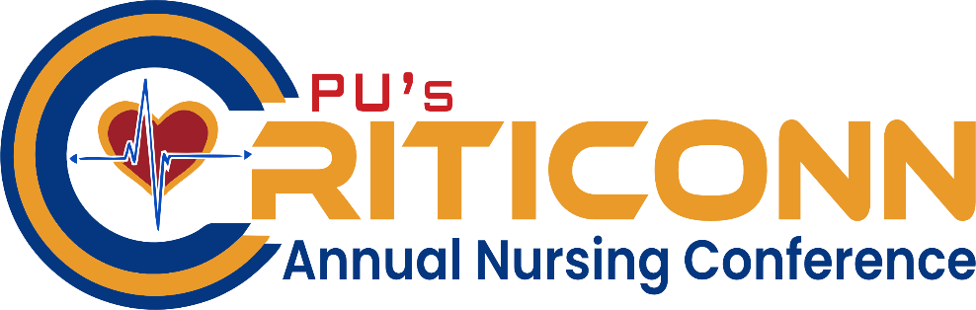
INTERNATIONAL CONFERENCE
ON
SMART NURSING AND HEALTHCARE INNOVATION
ADVANCING PREDICTIVE, CRITICAL AND PERSONALISED CARE THROUGH AI, DIGITAL TECHNOLOGIES AND NURSING-LED MULTIDISCIPLINARY INNOVATION

Pre Conference Workshop | Conference
18th February 2027 | 19th February 2027

Venue: Medical Auditorium, Parul University, Vadodara Gujarat

ORGANIZED BY
Faculty of Nursing, Parul University, Vadodara, and Gujarat.

WELCOME MESSAGE
It gives me immense pleasure to welcome all distinguished delegates, eminent speakers, researchers, healthcare professionals, academicians, innovators, and students to the International Conference on Smart Nursing and Healthcare Innovation, centred on the theme:
“Smart nursing and healthcare innovation advancing predictive, critical and personalised care through AI, digital technologies and nursing-led multidisciplinary innovation”
Healthcare is undergoing a remarkable transformation driven by advances in artificial intelligence, digital health technologies, predictive analytics, clinical decision-support systems, and multidisciplinary innovation. Within this rapidly evolving environment, nursing professionals have an increasingly important role in translating technological advancement into compassionate, evidence-based, safe, and personalised patient care.
This international conference provides a valuable platform for professionals from nursing, medicine, allied health sciences, engineering, technology, research, and academia to exchange knowledge, present innovative research, explore emerging technologies, and develop meaningful collaborations for the future of healthcare.
The Pre-Conference Workshop on “smart nursing and digital healthcare: from early detection to critical care and clinical decision-making” will further provide participants with opportunities to explore contemporary approaches to early detection, patient monitoring, critical care, clinical data interpretation, and technology-supported decision-making.
I am confident that the scientific deliberations, research presentations, expert interactions, and multidisciplinary discussions during this conference will inspire new ideas and contribute towards strengthening healthcare education, research, clinical practice, and innovation.
On behalf of Parul University, I extend a warm welcome to all participants and wish the International Conference on smart nursing and healthcare innovation great success.
Dr. Geetika Madan Patel
Vice President, Quality, Research and Health Sciences, Parul University
ABOUT CONFERENCE
The International Conference on Smart Nursing and Healthcare Innovation brings together nursing professionals, clinicians, researchers, engineers, and technology experts to advance predictive, critical, and personalised healthcare. The conference promotes nursing-led multidisciplinary innovation integrating artificial intelligence, digital health, smart technologies, clinical decision-making, and evidence-based research to improve patient outcomes.
ABOUT PARUL UNIVERSITY
Parul University, located in Vadodara, Gujarat, is a leading multidisciplinary private university committed to excellence in education, research, innovation, entrepreneurship, healthcare, technology, and global engagement. Accredited with the prestigious NAAC A++ Grade and recognised by the University Grants Commission (UGC) as a Category-1 University with Graded Autonomy, the University has also been notified as a Centre of Excellence by the Government of Gujarat.
Under the visionary leadership of Dr. Devanshu Patel, President, Parul University, the University has witnessed remarkable academic and infrastructural growth and today serves 70,000+ students, including 6,000+ international students from 75+ countries, while offering 200+ academic programmes across diverse disciplines.
Parul University has earned significant recognition in national rankings and assessments. In the NIRF India Rankings 2025, the University was placed in the 101–150 band among Universities in India, ranked among the Top 50 Institutions in India for Innovation, and secured 41st Rank nationally in Pharmacy. The University has also earned a 4/4 Star Rating from the Ministry of Education’s Institution’s Innovation Council (IIC). In the Outcome Based Education (OBE) Rankings 2026, Parul University was placed in the Platinum+ Band and among India’s Top 10 Institutions, while it also received the Platinum Band in the Sustainable Institutions of India – Green Rankings 2026.
Its growing global academic standing is further reflected through the QS I-GAUGE Diamond Rating, Platinum Subject Ratings in Medicine, Engineering and Pharmacy, recognition in the QS Asia University Rankings, and placement in the Times Higher Education Interdisciplinary Science and Sustainability Impact Rankings.
With a strong ecosystem of interdisciplinary research, innovation, advanced healthcare and academic infrastructure, industry partnerships, international collaborations, entrepreneurship, and socially responsive education, Parul University continues to strengthen its position as a progressive institution contributing to the transformation of higher education, healthcare, research, and innovation in India and beyond.

ABOUT THE FACULTY OF NURSING
The Faculty of Nursing, Parul University, is committed to excellence in nursing education, clinical practice, research and innovation, preparing competent and globally responsive nursing professionals. The Faculty offers nursing education from ANM and GNM to B.Sc. Nursing, Post Basic B.Sc. Nursing, M.Sc. Nursing and Ph.D. education, supported by hands-on clinical learning, advanced simulation and research opportunities. Its clinical education is strengthened by the 110--bedded Parul Sevashram Hospital, the Pragya Advanced Skills & Simulation Center, and community-based healthcare exposure. With an emphasis on evidence-based practice, interdisciplinary research, digital healthcare and compassionate patient-centred care, the Faculty provides a strong academic platform for advancing nursing-led healthcare innovation.
ABOUT CRITICONN 2027
The 4th CRITICONN International Conference, organized by the Faculty of Nursing, Parul University, will bring together nursing professionals, academicians, researchers, healthcare practitioners, and students from across the globe to explore transformative innovations in healthcare delivery. Aligned with the theme, “Advancing Predictive, Critical and Personalized Care through AI, Digital Technologies and Nursing-Led Multidisciplinary Innovation,” the conference will provide a dynamic platform for exchanging scientific evidence, presenting innovative research, and sharing best practices in critical care nursing, artificial intelligence, digital health, predictive healthcare, patient safety, and personalized care. Emphasizing interdisciplinary collaboration, evidence-based practice, and technological advancement, CRITICONN 2027 aims to foster nursing-led innovation, strengthen clinical decision-making, promote patient safety, and improve healthcare outcomes. The conference aspires to inspire meaningful collaborations, accelerate research translation into clinical practice, and contribute to shaping a future of healthcare that is intelligent, inclusive, safe, efficient, and patient-centred.

Conference Objectives
- To advance participants’ understanding of emerging trends in smart nursing, digital health, artificial intelligence, predictive analytics, and technology-enabled healthcare.
- To strengthen competencies in early detection, clinical surveillance, critical care, remote monitoring, and technology-supported clinical decision-making for safer and more effective patient care.
- To promote the integration of nursing science, clinical expertise, engineering, data science, and digital technologies in developing innovative and patient-centred healthcare solutions.
- To encourage the application of evidence-based, predictive, personalised, and digitally enabled care approaches across acute, critical, chronic, and community healthcare settings.
- To foster interdisciplinary and international collaboration in research, innovation, and responsible digital healthcare, with emphasis on patient safety, ethics, privacy, cybersecurity, and effective translation into clinical practice.

Pre-Conference Workshop Objectives
- To develop knowledge and practical understanding of smart healthcare technologies for early detection, patient monitoring, and clinical decision-making.
- To strengthen skills in integrating and interpreting EHR, laboratory, vital-sign, and clinical data for comprehensive patient assessment.
- To provide hands-on exposure to AI-assisted imaging and intelligent diagnostic technologies that support nursing and clinical decision-making.
- To develop practical skills in the application of wearable devices, sensors, IoT, and smart monitoring systems in acute and critical care.
- To strengthen competencies in the early recognition of clinical deterioration, interpretation of alerts, and timely escalation of care.
- To integrate technology-generated information with nursing assessment, clinical reasoning, and professional judgement to support safe, evidence-based, and person-centred care.

CONFERENCE SPARKERS / SESSION CHAIRPERSONS
 |  | 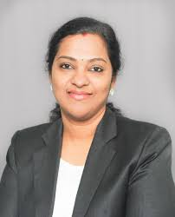 | 
Ms. Viktorija Kielė  Lecturer,  Faculty of Health Care  Vilniaus Kolegija (VIKO), Higher Education Institution  Vilnius, Lithuania, Europe | Dr. Jurgita Kazlauskienė  Vice-Dean, Faculty of Health Care  Vilnius University of Applied Sciences (VIKO)  Vilnius, Lithuania | Dr, Judie Arulappan  Associate Professor & Director, Nursing Laboratory and Simulation Unit (NLSU)  Certified Healthcare Simulation Educator (CHSE–SSH, USA)  Sultan Qaboos University, Sultanate of Oman | Dr. Gerald Amandu  Associate Professor, Leadership Management, Entrepreneurship, Sultan Qaboos University, Oman
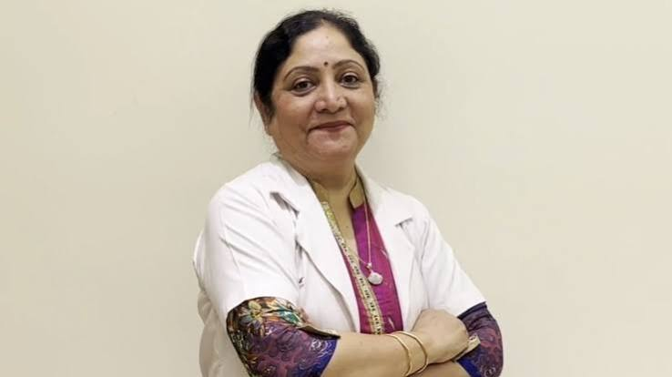 |  | 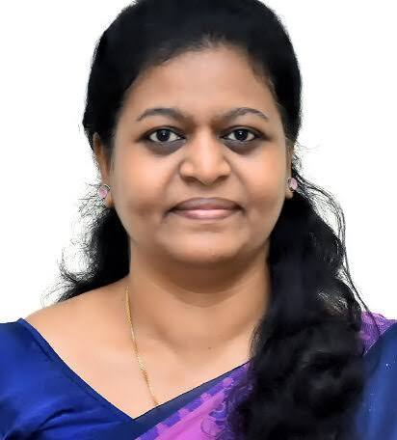 | 
Dr. Sukhpal Kaur  Professor cum Principal, National Institute of Nursing Education (NINE), PGIMER, Chandigarh | Dr. Kiran R. Amin  Deputy Pro Vice-Chancellor & Executive Dean  Faculty of Engineering & Technology, Ganpat University, Gujarat, India | Dr. Sheela Durai,  Professor and HOD, Surgical Nursing, Simulation Center Director, College of Nursing, Christian Medical College, Vellore. | Prof. (Dr.) Harmeet Kaur Kang  Director, Chitkara School of Health Sciences, Chitkara University, Punjab.
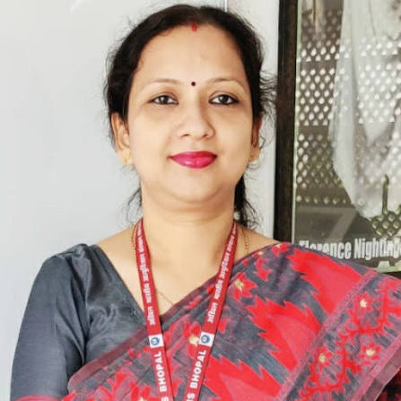 |  | 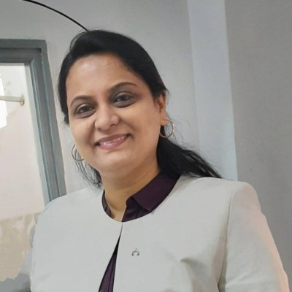 | 
Prof. (Dr.) Lilly Podder  Associate Professor  Department of Obstetrics & Gynaecology Nursing  Faculty of Nursing  All India Institute of Medical Sciences (AIIMS), Bhopal  Madhya Pradesh, India | Harikrishnan Ramachandran  Professor  Department of Electronics and Telecommunication Engineering, Symbiosis Institute of Technology (SIT) Pune. | Prof. (Dr.) Ketki Pathak  Associate Professor, Electronics & Communication Depatment at Sarvajanik College of Engineering and Technology, Surat, Gujarat, India | Dr. Shilpa Bade-Gite  Professor, Computer Science  University of York, Mumbai,  Maharashtra, India
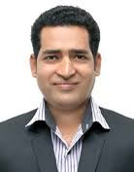 | 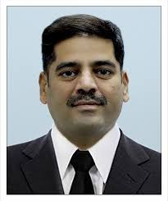 |  | 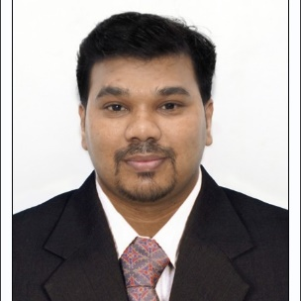
Dr. Satish Biradar  Registrar, P. P. Savani University  Surat, Gujarat, India | Dr. Ravindra H. N  Dean, ITM College of Nursing and Director of Paramedical Programs at ITM SLS Baroda University Vadodara, Gujarat, India | Dr. Hemant Kumar Patadia  Professor & Principal, Parul Institute of Allied and Healthcare Sciences, Faculty of Medicine, Parul University, Vadodara, Gujarat | Dr. Ramji Gupta  R & D Member, Assistant Professor, Parul Institute of Engineering & Technology (PIET), Parul University, Vadodara, Gujarat, India
 |  | 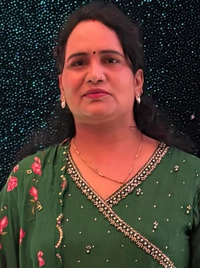 | 
Dr. Anita Prakashan  Dean, Faculty of Nursing  Sumandeep Vidyapeeth  Vadodara, Gujarat, India | Dr. Siddaram Sarate  Principal  College of Nursing  CVM University  Gujarat, India | Ms. Indravati Pandey  Principal  Government College of Nursing  Surat, Gujarat, India | Dr. Vithoba Narayan Mhalkar  Associate Professor , Institute of Psychiatry & Human Behaviour Bambolim, Goa
 |  | 
Venkateswarlu Gonuguntla  Associate Professor and Research Faculty  Quantum AI School for Advanced Research  Alliance University, Bengaluru, India. |  | Dr. Nivedita Gupta  Associate Professor Research Cadre, Parul Inst. of Allied Healthcare Sciences, Parul University, Vadodara, Gujarat

Conference Leadership
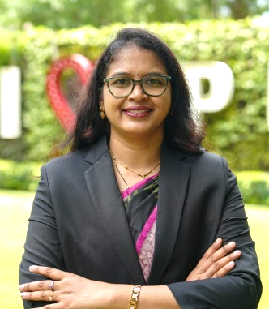 | 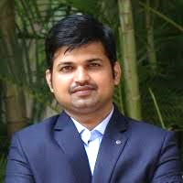 | 
Conference Chairperson  Dr. Seeta Devi Penta  Dean, Faculty of Nursing and Principal, Parul Institute of Nursing, Parul University, Vadodara, Gujarat. | Conference Co Convenor  Dr. Devraj Singh Chouhan  Principal  Parul Institute of Nursing And Research , Faculty of Nursing  Parul University, Vadodara, Gujarat, India | Organizing Secretary  Dr. Swapnil Rahane  Associate Professor, Ph.D. Coordinator, Faculty of Nursing Parul Institute of Nursing, Parul University, Vadodara, Gujarat.

PRE-CONFERENCE WORKSHOP
SMART NURSING AND DIGITAL HEALTHCARE: FROM EARLY DETECTION TO CRITICAL CARE AND CLINICAL DECISION-MAKING
18th February 2027
PRE-CONFERENCE WORKSHOP SCHEDULE
Venue: Medical College Auditorium, Parul University, Vadodara, Gujarat

TIME | Workshop | RESOURCE PERSONS
08:30 - 09:00 AM | Participant Registration, Networking And Breakfast
09:00 - 10:00 AM | WORKSHOP I - From Patient Data to Bedside Decisions: Advancing Evidence-Based Nursing and Clinical Care  Workshop Highlights: EHR, laboratory, vital-sign and clinical data integration for pattern recognition and decision support. | - Dr. Sheela Durai, Ph.D. HOD, Medical & Surgical Nursing, College of Nursing, Christian Medical College, Vellore.  - Dr. Jurgita Kazlauskienė  Vice-Dean, Faculty of Health Care  Vilnius University of Applied Sciences (VIKO), Vilnius, Lithuania  - Dr. Ramji Gupta, R & D Member, Assistant Professor, Parul Institute of Engineering & Technology (PIET), Parul University, Vadodara, Gujarat, India
10:30 - 11:00 AM | WORKSHOP II - Intelligent Imaging in Smart Nursing: From Visual Detection to Clinical Decision-Making Workshop Highlights: AI-assisted X-ray, CT, ultrasound and imaging technologies for nursing assessment and acute/critical care decisions. | - Venkateswarlu Gonuguntla, Associate Professor and Research Faculty, Quantum AI School for Advanced Research, Alliance University, Bengaluru, India.  - Prof. (Dr.) Harmeet Kaur Kang  Director, Chitkara School of Health Sciences, Chitkara University, Punjab.
11:00 - 11:15 AM | Tea Break & Networking
11:15 AM - 12:15 PM | WORKSHOP III - Smart Monitoring in Critical Care Nursing: From Real-Time Data to Early Recognition and Timely Intervention  Workshop Highlights: Wearables, sensors, IoT devices, smart monitoring and alarms; interpreting patient trends and alerts for safer care. | - Dr, Judie Arulappan, Associate Professor & Director, Nursing Laboratory and Simulation Unit (NLSU), Certified Healthcare Simulation Educator (CHSE–SSH, USA), Sultan Qaboos University, Sultanate of Oman  - Harikrishnan Ramachandran, Professor, Department of Electronics and Telecommunication Engineering, Symbiosis Institute of Technology (SIT) Pune.
12:15 - 01:00 PM | Lunch Break & networking
01:00 - 02:00 PM | WORKSHOP IV - Smart Nursing Surveillance: Early Recognition and Response to Clinical Deterioration  Workshop Highlights: Physiological trends, early-warning scores, technology-supported alerts, escalation and timely intervention. | Prof. (Dr.) Ketki Pathak,  Associate Professor, Electronics & Communication Depatment at Sarvajanik College of Engineering and Technology, Surat, Gujarat, India  - Dr. Shilpa Bade-Gite  Professor of Computer Science  University of York, Mumbai  Mumbai, Maharashtra
02:00 - 03:30 PM | WORKSHOP V - Human-Technology Integration: Smart Healthcare with Nursing and Clinical Judgment  Workshop Highlights: Interactive simulation balancing patient assessment, clinical judgment, monitoring data and smart alerts. | - Dr. Gerald Amandu  Associate Professor, Leadership, Management, Entrepreneurship, Sultan Qaboos University, Oman  - Dr. Sukhpal Kaur  Professor cum Principal at the National Institute of Nursing Education (NINE), PGIMER, Chandigarh
03:30 - 03:45 PM | Tea Break & Networking
03:45 - 05:00 PM | Key Takeaways, Feedback & Closing Remarks

INTERNATIONAL CONFERENCE
ON
SMART NURSING AND HEALTHCARE INNOVATION
ADVANCING PREDICTIVE, CRITICAL AND PERSONALISED CARE THROUGH AI, DIGITAL TECHNOLOGIES AND NURSING-LED MULTIDISCIPLINARY INNOVATION
19th February 2027
CONFERENCE SCHEDULE
Venue: Medical College Auditorium, Parul University, Vadodara, Gujarat
08:00 – 09:00 AM | Scientific Sessions | Speakers | Session Chairperson
09:00 - 09: 45 AM | Scientific Session: 01  The Digital Heart: Advancing Nursing Research and Evidence for Early Detection & Personalized Cardiovascular Care | Dr, Judie Arulappan, Associate Professor & Director, Nursing Laboratory and Simulation Unit (NLSU), Certified Healthcare Simulation Educator (CHSE–SSH, USA), Sultan Qaboos University, Sultanate of Oman | Dr. Hemant Kumar Patadia  Professor & Principal, Parul Institute of Allied and Healthcare Sciences, Faculty of Medicine, Parul University, Vadodara, Gujarat
9:45 - 10:30 AM | Scientific Session: 02  Precision Oncology Nursing: Next-Gen Evidence for Early Detection & Personalized Cancer Care | Dr. Kiran R. Amin  Deputy Pro Vice-Chancellor & Executive Dean  Faculty of Engineering & Technology, Ganpat University, Gujarat, India | Dr. Anita Prakashan  Dean, Faculty of Nursing  Sumandeep Vidyapeeth  Vadodara, Gujarat, India
10:30AM – 10:45 AM | Tea Break & Networking
10:45 – 11:30 AM | Inauguration
11:30 AM-12:00 PM | Scientific Session: 03  Time Is Brain: Smart Nursing and Next-Gen Evidence for Early Recognition & Rapid Stroke Care | Venkateswarlu Gonuguntla  Associate Professor and Research Faculty  Quantum AI School for Advanced Research  Alliance University, Bengaluru, India. | Dr. Satish Biradar  P. P. Savani University  Surat, Gujarat, India
12:00 PM – 12:45 PM | Scientific Session: 04  Smart Nursing in Diabetes Care: Digital Innovation for Early Detection, Prediction and Personalised Management | Prof. (Dr.) Harmeet Kaur Kang  Director, Chitkara School of Health Sciences, Chitkara University, Punjab. | Dr. Ravindra H. N  Dean, ITM College of Nursing and Director of Paramedical Programs at ITM SLS Baroda University Vadodara, Gujarat, India
12:45 PM- 1:30 PM | Scientific Session: 05  Smart Maternal & Newborn Care: Next-Gen Nursing & Midwifery Evidence for Risk Prediction and Personalised midwifery Care | Prof. (Dr.) Lilly Podder  Associate Professor  Department of Obstetrics & Gynaecology Nursing  Faculty of Nursing  All India Institute of Medical Sciences (AIIMS), Bhopal  Madhya Pradesh, India | Dr. Seeta Devi  Dean, Faculty of Nursing  Parul University  Vadodara, Gujarat, India
01:30 – 02:15 PM | Lunch Break & Networking
Parallel Scientific Sessions  02:15 – 03:45 PM | Parallel Scientific Sessions  Venue: Seminar Hall, Third Floor, Medical College, Parul University, Vadodara, Gujarat  Scientific Poster Presentations  Venue: Medical College Auditorium, Parul University, Vadodara, Gujarat
02:15 – 03:00 PM | Scientific Session: 06  Breathing Smarter: Connected Technologies for Predictive & Personalised Respiratory Nursing Care | Dr. Shilpa Bade-Gite  Professor of Computer Science  University of York, Mumbai  Mumbai, Maharashtra, India | Dr. Indravati Pandey  Principal  Government College of Nursing  Surat, Gujarat, India
03:00 – 03:45 PM | Scientific Session: 07  Ageing Smarter: Digital Innovation and Nursing Evidence for Healthy, Independent and Person-Centred Ageing | Ms. Viktorija Kielė  Lecturer, Faculty of Health Care  Vilniaus Kolegija (VIKO), Higher Education Institution  Vilnius, Lithuania, Europe | Dr. Siddaram Sarate  Principal  College of Nursing  CVM University  Gujarat, India
03:45 – 04:00 PM | Tea Break
04:00 – 04:45 PM | Scientific Session: 08  Next-Generation Mental Health Nursing: Digital Innovation for Early Detection and Personalised Care | Dr. Vithoba Narayan Mhalkar  Associate Professor , Institute of Psychiatry & Human Behaviour Bambolim, Goa | Dr. Nivedita Gupta  Associate Professor Research Cadre, Parul Inst. of Allied Healthcare Sciences, Parul University, Vadodara, Gujarat
04:45 PM – 5:00 PM | Scientific Paper / Poster Award Distribution & Valedictory Session

CALL FOR PAPERS / ABSTRACTS
INTERNATIONAL CONFERENCE
ON
SMART NURSING AND HEALTHCARE INNOVATION
ADVANCING PREDICTIVE, CRITICAL AND PERSONALISED CARE THROUGH AI, DIGITAL TECHNOLOGIES AND NURSING-LED MULTIDISCIPLINARY INNOVATION

Conference Dates: 18–19 February 2027
We are pleased to invite researchers, academicians, nursing professionals, healthcare practitioners, clinicians, technologists, innovators, postgraduate scholars, and students to participate in the International Conference on Smart Nursing and Healthcare Innovation, to be held on 18–19 February 2027, under the theme “Advancing Predictive, Critical and Personalised Care through AI, Digital Technologies and Nursing-Led Multidisciplinary Innovation.”
The conference aims to provide a dynamic interdisciplinary platform for the exchange of emerging research, innovative technologies, evidence-based practices, and transformative healthcare solutions that can contribute to smarter, safer, predictive, personalised, and patient-centred care. It will bring together experts and participants from Nursing, Medicine, Allied Health Sciences, Biomedical Engineering, Artificial Intelligence, Data Science, Digital Health, Public Health, Academia, Research, and the Healthcare Industry to share knowledge, foster multidisciplinary collaboration, and explore contemporary challenges and emerging opportunities in healthcare innovation.
Original research and review abstracts are invited for Oral Paper and Poster Presentations. Submissions may include original research studies, innovative clinical and nursing practices, technological and digital health innovations, implementation research, quality-improvement initiatives, systematic and scoping reviews, evidence-based practice projects, and interdisciplinary healthcare innovations aligned with the conference theme and scientific tracks.
SCIENTIFIC THEMATIC TRACKS FOR ABSTRACTS, ORAL PAPERS & POSTERS
Track 1 – Artificial Intelligence, Machine Learning & Predictive Healthcare
AI-enabled healthcare, machine learning, predictive analytics, risk prediction, disease forecasting, intelligent screening, and AI-assisted clinical care.
Track 2 – Smart Nursing, Nursing Informatics & Digital Transformation
Nursing informatics, smart nursing practices, digital nursing documentation, AI-supported nursing care, nursing-led innovation, digital competency, and technology-enabled nursing education.
Track 3 – Digital Health, Telehealth, IoMT, Wearables & Remote Patient Monitoring
Telemedicine, mobile health, Internet of Medical Things, wearable technologies, remote monitoring, digital therapeutics, virtual care, and connected healthcare systems.
Track 4 – Biomedical Imaging, Intelligent Diagnostics & Clinical Decision Support
AI-assisted imaging, intelligent diagnostic systems, clinical decision-support technologies, point-of-care diagnostics, automated interpretation, and precision diagnostics.
Track 5 – Smart Critical Care, Emergency Medicine & Early Warning Systems
Critical-care technologies, emergency-care innovations, early warning scores, patient deterioration prediction, smart ICUs, rapid response systems, resuscitation science, and acute-care decision support.
Track 6 – Personalised Digital Care for Cardiovascular, Neurological & Chronic Diseases
Personalised care pathways, cardiovascular and stroke technologies, neurological monitoring, chronic disease management, rehabilitation technologies, digital follow-up, and predictive care models.
Track 7 – Smart Maternal, Newborn, Child, Mental Health & Healthy Ageing Technologies
Maternal and newborn monitoring, paediatric innovations, digital mental-health interventions, behavioural technologies, geriatric care, healthy ageing, and technology-supported family-centred care.
Track 8 – Biomedical Engineering, Medical Devices, Robotics & Assistive Healthcare Technologies
Innovative medical devices, biomedical engineering solutions, healthcare robotics, rehabilitation devices, simulation technologies, assistive technologies, prototypes, and healthcare product innovation.
Track 9 – Healthcare Data Science, Electronic Health Records & Intelligent Health Systems
Healthcare analytics, electronic health records, big data, interoperability, clinical data integration, smart hospital systems, health-information systems, and population-health analytics.
Track 10 – Responsible AI, Cybersecurity, Privacy, Ethics & Governance in Digital Healthcare
Ethical AI, patient privacy, cybersecurity, responsible innovation, algorithmic transparency, data protection, regulatory considerations, digital-health governance, and safe adoption of emerging technologies.

IMPORTANT DATES
Call for Abstracts & Full Papers Opens: 31 October 2026
Abstract Submission Deadline: 30 November 2026
Notification of Abstract Acceptance: 30 December 2026
Early-Bird / Author Registration Deadline: 10 January 2027
Full Paper Submission Deadline: 15 January 2027
Notification of Full Paper Review Decision: 25 January 2027
Final Revised / Camera-Ready Paper Submission: 30 January 2027
Final Author Registration Deadline: 30 January 2027

ABSTRACT SUBMISSION GUIDELINES
- Conference registration is mandatory for all presenting authors and co-authors.
- Abstracts should not exceed 250 words.
- The abstract must be original, unpublished, and free from plagiarism.
- Authors are requested to check the manuscript before submission. The similarity index should preferably be below 10%, add AI.
- Authors are responsible for ensuring the originality and academic integrity of all submitted content, including appropriate disclosure and responsible use of AI-assisted tools, where applicable.
- Mode of Presentation: Offline / In-Person.
- Abstracts may be submitted under the following categories:
    - Original Research/ Empirical Research
    - Systematic / Scoping / Narrative Reviews
    - AI/ Innovation / Technology-Based Studies
- The abstract should be submitted under one of the designated conference tracks.
- Only abstracts submitted within the prescribed timeline and format will be considered for scientific review.

AUTHOR DETAILS
Each abstract submission should include:
- Name of the Presenting Author
- Name of the Corresponding Author
- Names of all Co-authors, if applicable
- Designation and institutional affiliation of all authors
- Official email ID of the presenting/corresponding author
- Contact details of the corresponding author
- Selected Conference Track / Theme

STRUCTURED ABSTRACT FORMAT
The abstract should provide a concise summary of the study and contain the following:
- Title of the abstract.
- Background: Briefly introduce the context and significance of the research problem.
- Objectives: State the specific aim or objectives of the study.
- Methods: Describe the study design, methodology, and data collection techniques.
- Results: Present the main findings or outcomes of the study.
- Conclusion: Summarize the implications of the findings and their significance in the broader context of the field.
- Keywords: List 3–5 keywords or phrases that capture the essence of the study.

REVIEW, PRESENTATION & PUBLICATION PROCESS
- All abstracts will be reviewed by the Scientific Committee for relevance, scientific quality, originality, methodological appropriateness, and alignment with the conference theme.
- Abstracts must follow the prescribed submission format. Submissions requiring minor corrections may be returned to the authors for revision.
- Following scientific review, selected abstracts will be accepted for Oral Paper Presentation or Poster Presentation.
- Presenters of selected abstracts will be invited to submit a Full-Length Manuscript in accordance with the prescribed author guidelines.
- Full-length manuscripts submitted for publication will undergo a separate scientific, editorial, and peer-review process.
- Selected high-quality manuscripts may be considered for publication in the Conference Proceedings/Compendium and/or for submission to associated peer-reviewed and indexed journals.
- Manuscripts accepted by the respective journal after completion of its editorial and peer-review process will be published in accordance with the journal’s policies, standards, and author guidelines.
- Article Processing Charges (APC), publication fees, or other applicable charges, wherever applicable, shall be payable as per the policies of the respective journal or publisher.
- The conference will facilitate publication opportunities for suitable manuscripts; however, the final decision regarding manuscript acceptance, publication, and indexing will rest with the respective journal editorial board/publisher.
- Publication in any specific database, including Scopus, Web of Science, or other indexing services, will depend on the indexing status and policies of the respective journal at the time of publication.
- Acceptance of an abstract for conference presentation and acceptance of a full-length manuscript for publication will be treated as separate review processes.
- The decision of the Scientific Committee and Jury regarding abstract acceptance, presentation category, and conference awards shall be final.

Conference Registration Fees
Sr. No. | Category | Pre-Conference Workshop (₹) | Main Conference (₹) | Combo Registration (Workshop + Conference) (₹)
1 | Undergraduate / Postgraduate Student | 1,500 INR | 1,500 INR | 3,000 INR
2 | Research Scholar / PhD Scholar/Faculty / Clinician / Healthcare Professional | 2,000 INR | ₹3,500 INR | 5,500 INR
4 | Industry Professional | 2,000 INR | ₹3,500 INR | 5,500 INR
5 | Paper Co-author / Attendee Only* | 2,000 INR | ₹3,500 INR | 5,500 INR

Note: Registration Fee Includes access to the registered workshop/conference sessions, delegate materials/kit, refreshments and lunch, certificates, networking/exhibition access, and digital abstract book/proceedings, wherever applicable.
Travel, accommodation, local transportation and personal expenses are not included in the registration fee.
REGISTER NOW | SUBMIT YOUR ABSTRACT
Registration Link: https://forms.gle/NMS6ReDw8xgp8X1Z6
Conference website
http://criticon-conference.paruluniversity.ac.in/

AWARDS & CASH PRIZES
Category | Prize | Cash Award | Recognition
Best Paper Presentation | 1st Prize | ₹10,000 | Trophy + Certificate
Best Paper Presentation | 2nd Prize | ₹5,000 | Trophy + Certificate
Best Paper Presentation | 3rd Prize | ₹3,000 | Trophy + Certificate
Best Poster Presentation | 1st Prize | ₹10,000 | Trophy + Certificate
Best Poster Presentation | 2nd Prize | ₹5,000 | Trophy + Certificate
Best Poster Presentation | 3rd Prize | ₹3,000 | Trophy + Certificate
Smart Innovation Research Impact Award | Special Award | ₹11,000 | Trophy + Certificate

CALL FOR SPONSORSHIP & INDUSTRY PARTNERSHIP
Smart Healthcare: From Early Detection to Critical Care and Clinical Decision-Making
Date: 18-19 February 2026 Venue: Parul University, Vadodara, Gujarat, India

Why Partner With Us?
Sponsoring the conference provides organizations with an opportunity to:
- Enhance institutional and corporate visibility among healthcare professionals, academicians, researchers and students.
- Showcase healthcare technologies, products, services and innovations.
- Engage with nurses, clinicians, healthcare educators, researchers, engineers and decision-makers.
- Build academic-industry collaborations and professional networks.
- Support innovation, research and evidence-based healthcare.
- Promote products and services through conference branding and exhibition opportunities.
- Demonstrate commitment to nursing advancement, healthcare innovation and professional development.

Proposed Sponsorship Categories
Sponsorship Category | Contribution | Major Benefits
Platinum Sponsor | ₹1,00,000 | Premium logo placement, prominent conference branding, exhibition space, acknowledgement during inaugural and valedictory sessions, promotional material inclusion, complimentary registrations and certificate/memento
Gold Sponsor | ₹75,000 | Prominent logo placement, exhibition space, acknowledgement during conference sessions, promotional material inclusion and complimentary registrations
Silver Sponsor | ₹50,000 | Logo on selected conference materials, exhibition/display opportunity, acknowledgement and complimentary registrations
Associate Sponsor | ₹25,000 | Logo visibility on selected promotional materials, acknowledgement and complimentary registration

Bank account detail for payment
Particulars | Bank Account Details
Bank Name | Central Bank of India (CBI)
Account Name | R & D Centre Unit of Parul University
Account Number | 3793150745
IFSC Code | CBIN0284063
Branch Name | PIET, Limda

Contact for Sponsorship Queries

Dr. Swapnil Rahane  Organizing Secretary  Associate Professor, PhD Coordinator, Parul Institute of Nursing, Faculty of Nursing  Parul University, Vadodara, Gujarat, India  Mobile: +91 95112 39601  Email: criticonn@paruluniversity.ac.in | Mrs. Steffy Abraham  Associate Professor, Parul Institute of Nursing, Faculty of Nursing  Parul University, Vadodara, Gujarat, India  Mobile: +91 9033880267

CONFERENCE CONTACTS & ENQUIRIES
Contact for registration
Ms. Heena Baria  Assistant Professor  Parul Institute of Nursing, Faculty of Nursing  Parul University, Vadodara, Gujarat, India  Mobile: +91 9537885638 | Ms. Sandhya Kumari Rajbhar  Assistant Professor  Parul Institute of Nursing, Faculty of Nursing  Parul University, Vadodara, Gujarat, India  Mobile: +91 79904 56089 | Dr. Jeba Khatun  Assistant Professor, Parul Institute of Nursing and research, Faculty of Nursing  Parul University, Vadodara, Gujarat, India  Mobile: +91 7623903287
Contact for Scientific Abstract (paper &Poster) Submission Queries
Prof. Takhellambam Kiranmala Chanu  Professor, Vice Principal & Head, Department of Obstetrics & Gynaecological Nursing, Parul Institute of Nursing, Faculty of Nursing.  Mobile: +91 99975 31367 | Dr. Abhya Pattan  Professor, Head, Department of Community Health Nursing, Parul Institute of Nursing, Faculty of Nursing  Parul University, Vadodara, Gujarat, India  Mobile: +91 98444 38332 | Dr. Roma Patel  Associate Professor, Department of Child Health Nursing, Parul Institute of Nursing, Faculty of Nursing  Parul University, Vadodara, Gujarat, India  Mobile: +91 8160127238
Contact for Accommodation & Hospitality Assistance
Ms. Manish Trivedi  Associate Professor  Parul Institute of Nursing, Faculty of Nursing  Parul University, Vadodara, Gujarat, India  Mobile: +91 7990715967 | Mr. Bhavik Bhatt  Nursing Tutor  Parul Institute of Nursing, Faculty of Nursing  Parul University, Vadodara, Gujarat, India  Mobile: +91 7728850919
General Conference Enquiries & Coordination
Dr. Seeta Devi Penta  Conference Chairperson  Dean, Faculty of Nursing and Principal, Parul Institute of Nursing at Parul University, Vadodara, Gujarat.  Mobile: +91 9665539533  Email: dean.pin@paruluniversity.ac.in | Dr. Swapnil Rahane  Organizing Secretary  Associate Professor, Parul Institute of Nursing, Faculty of Nursing  Parul University, Vadodara, Gujarat, India  Mobile: +91 95112 39601  Email: criticonn@paruluniversity.ac.in

